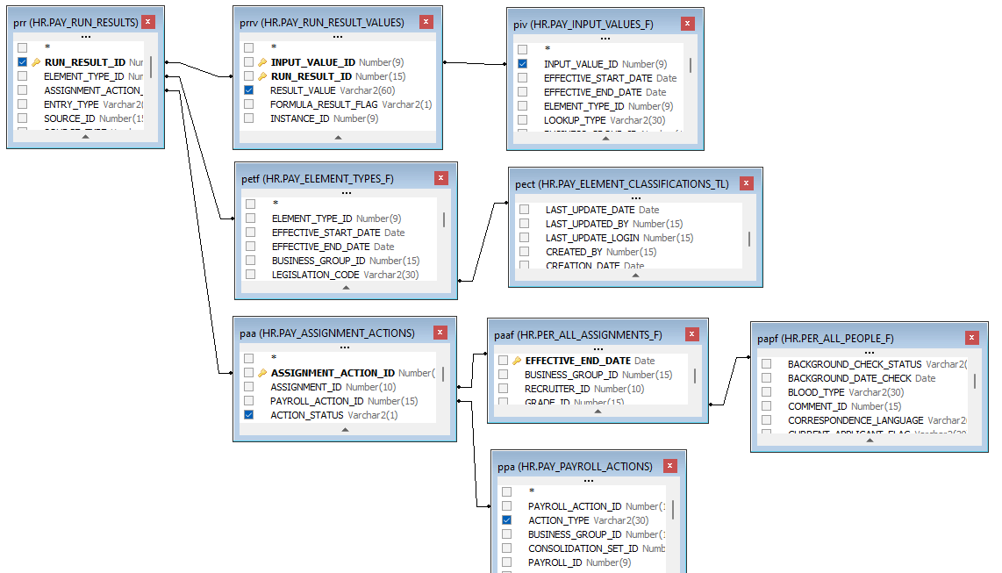

Select

prr.RUN_RESULT_ID,

prrv.RESULT_VALUE,

piv.UOM,

piv.NAME,

piv.INPUT_VALUE_ID,

petf.ELEMENT_NAME,

pect.CLASSIFICATION_NAME,

ppa.ACTION_TYPE,

ppa.EFFECTIVE_DATE,

paa.ACTION_STATUS,

paaf.ASSIGNMENT_NUMBER,

papf.PERSON_ID,

papf.EMPLOYEE_NUMBER,

papf.FULL_NAME,

paaf.ORGANIZATION_ID

From

HR.PAY_RUN_RESULTS prr,

HR.PAY_RUN_RESULT_VALUES prrv,

HR.PAY_INPUT_VALUES_F piv,

HR.PAY_ELEMENT_TYPES_F petf,

HR.PAY_ELEMENT_CLASSIFICATIONS_TL pect,

HR.PAY_PAYROLL_ACTIONS ppa,

HR.PAY_ASSIGNMENT_ACTIONS paa,

HR.PER_ALL_ASSIGNMENTS_F paaf,

HR.PER_ALL_PEOPLE_F papf

Where

prr.RUN_RESULT_ID = prrv.RUN_RESULT_ID And

piv.INPUT_VALUE_ID = prrv.INPUT_VALUE_ID And

petf.ELEMENT_TYPE_ID = prr.ELEMENT_TYPE_ID And

pect.CLASSIFICATION_ID = petf.CLASSIFICATION_ID And

prr.ASSIGNMENT_ACTION_ID = paa.ASSIGNMENT_ACTION_ID And

paa.PAYROLL_ACTION_ID = ppa.PAYROLL_ACTION_ID And

paa.ASSIGNMENT_ID = paaf.ASSIGNMENT_ID And

ppa.PAYROLL_ACTION_ID = paa.PAYROLL_ACTION_ID And

papf.PERSON_ID = paaf.PERSON_ID And

piv.UOM = 'M' And

piv.NAME = 'Pay Value' And

pect.CLASSIFICATION_NAME In ('Normal Income', 'Allowances') And

paa.ACTION_STATUS = 'C' And

ppa.ACTION_TYPE In ('R') And

ppa.EFFECTIVE_DATE Between Trunc(paaf.EFFECTIVE_START_DATE) And Trunc(paaf.EFFECTIVE_END_DATE) And

Trunc(paaf.EFFECTIVE_END_DATE) Between papf.EFFECTIVE_START_DATE And papf.EFFECTIVE_END_DATE

NOTE: Add to select dates

ppa.effective_date Between '01-MAR-2022' And '31-DEC-2022' And